**BX3081: INTERACTIVE MARKETING**

ASSESSMENT TASK 2 COLLEGE OF BUSINESS, LAW AND GOVERNANCE



**INDIVIDUAL TASK COVER SHEET**

|  |  |  |  |  |  |  |  |  |  |
| --- | --- | --- | --- | --- | --- | --- | --- | --- | --- |
| *Student*  *Please sign, date and attach cover sheet to front of assessment task for all hard copy submissions* | | | | | | | | | |
| **SUBJECT CODE** | BX3081 | | | | | | | | |
| **STUDENT FAMILY NAME** | **Student Given Name** | **JCU Student Number** | | | | | | | |
| Tran | Le Binh | 1 | 3 | 4 | 7 | 6 | 1 | 1 | 2 |
| **ASSESSMENT TITLE** | Social Media Project | | | | | | | | |
| **DUE DATE** | 21/9/2018 | | | | | | | | |
| **LECTURER NAME** | Pamela Wildheart Pilapil | | | | | | | | |
| **TUTOR NAME** | Pamela Wildheart Pilapil | | | | | | | | |
| **Student Declaration**   1. This assignment is my original work and no part has been copied/ reproduced from any other person’s work or from any other source, except where acknowledgement has been made (see *Learning, Teaching and Assessment Policy 5.1*). 2. This work has not been submitted for any other course/subject (see *Learning, Teaching and Assessment Policy 5.9*). 3. This assignment has not been written for me. 4. I hold a copy of this assignment and can produce a copy if requested. 5. This work may be used for the purposes of moderation and identifying plagiarism. 6. I give permission for a copy of this marked assignment to be retained by the College for benchmarking and course review and accreditation purposes.   [Learning, Teaching and Assessment Policy](http://www.jcu.edu.au/policy/allitoz/JCU_076643.html) 5.1. A student who submits work containing plagiarised material for assessment will be subject to the provisions of the [Student Academic Misconduct Requirements.](http://www.jcu.edu.au/policy/allitoz/JCUDEV_005375.html)  **Note definition of plagiarism and self plagiarism in Learning, Teaching and Assessment Policy:**  **Plagiarism:** reproduction without acknowledgement of another person’s words, work or expressed thoughts from any source. The definition of words, works and thoughts includes such representations as diagrams, drawings, sketches, pictures, objects, text, lecture hand-outs, artistic works and other such expressions of ideas, but hereafter the term ‘work’ is used to embrace all of these. Plagiarism comprises not only direct copying of aspects of another person’s work but also the reproduction, even if slightly rewritten or adapted, of someone else’s ideas. In both cases, someone else’s work is presented as the student’s own. Under the Australian *Copyright Act 1968* a copyright owner can take legal action in the courts against a party who has infringed their copyright.  **Self Plagiarism:** the use of one’s own previously assessed material being resubmitted without acknowledgement or citing of the original.  **Student Signature**  **Tran Le Binh Submission date 21/ 09/ 2018** | | | | | | | | | |



# Introduction

The Hipo Medical Care company is the pioneer in the field of supplying the innovative medical products. It is significant to acknowledge that protecting and caring for health is a critical and urgent issue because the environment is increasingly contaminated from food to air around the world. This is the reason why the company creates the Hipo Medical Care product. The product brings about the home health care check-up to the consumers, which helps the consumers save their time in the hectic days. The product is suitable for young families with children, SINKS/DINKS, elderly people, couples, empty nesters. The machine functions include check blood pressure, urine and weather condition. The patients are able to check their physical examination at home so that it makes their life more convenient. The machine connects with Bluetooth, Internet through desktop and smartphones so that all health record will send directly to hospitals and doctors.

Therefore, the invention of this product becomes a breakthrough in the medical field. In order to make the product become popular in the market, the product will be advertised on three different social media platforms such as Facebook, Instagram and Wikipedia by creating the business fan page. There is the fact that on Facebook, there are about 1.32 billion daily active users and 50 million pages for the purpose of business (Donnelly, 2018). For Instagram, there are about 1 billion users use Instagram and about 25 million business profiles exists on this platform (Mathison, 2018). For Wikipedia, there are about 33.6 million users (Smith, 2018). A various users utilizing three platforms make the company believes that the utilization of these platforms to advertise the company brand and products boosts the higher level of competitive advantage than other competitors and access the suitable target market.

The app link: <https://youtu.be/cysoPqOr5UA>

# Facebook

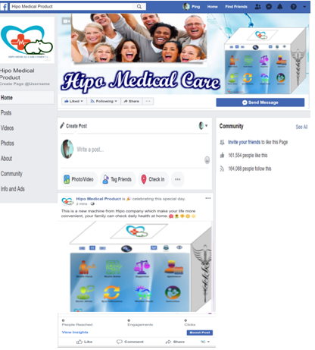

# Instagram

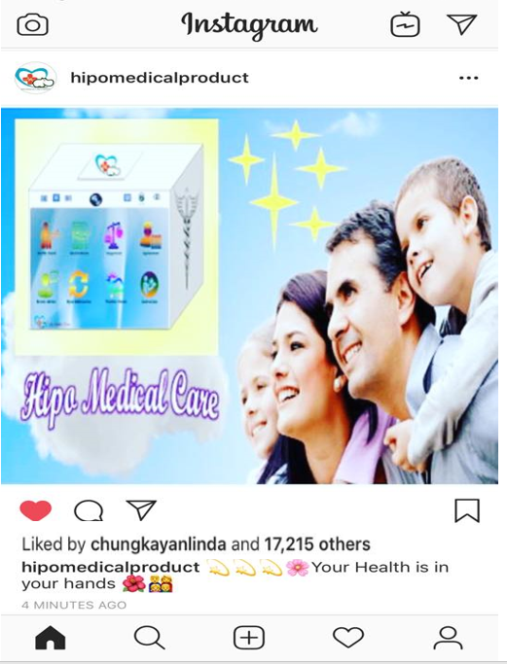

# Wikipedia

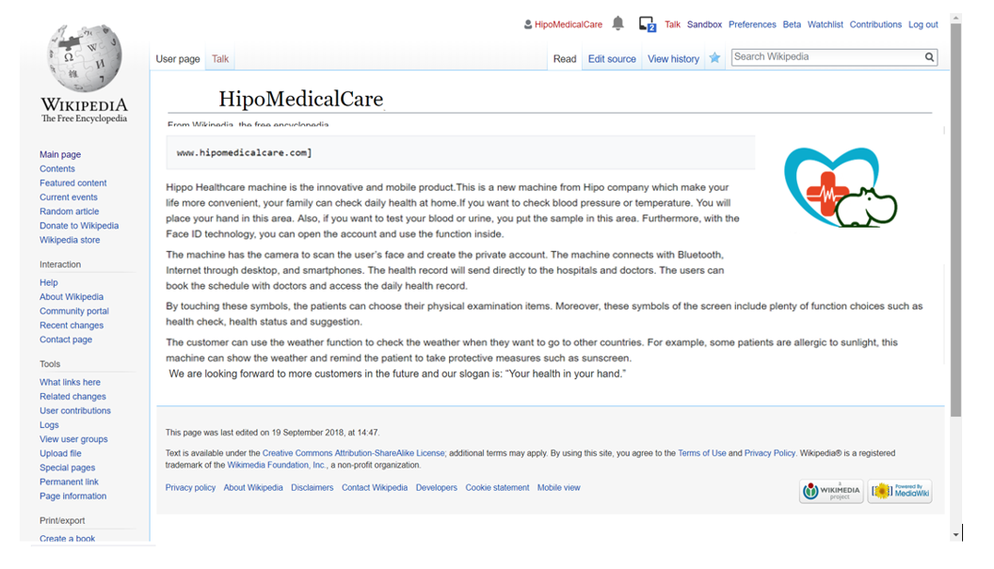

# Explanation

The company chooses Facebook platform to advertise the brand by using the function of reminder and notification to draw the attention from the customers about the company lasted news. There is the introduction about the company performance, achievements by displaying the image of company and some qualified certificates. The company publishes daily posts about the latest products with the photos, videos where the products’ description, functions and price is provided to the customers. The consumers are able to express their thoughts and emotions about the products by making a comment on each post or using captions. If the consumers want to interact with company, they can click the “Send message” to share their opinions. The company analyses the negative and positive feedback to comprehend the customers’ satisfaction about the company products.

However, Facebook is the public social networking site. The strangers can post their status, comment negative and biased viewpoints or upload the files on the company page. It is significant to notice that hackers are easy to penetrate the company page to distort the fame of the company. Therefore, the company ought to consider prudently when choosing Facebook platform to advertise the company image and provide against any intentional incidents.

Another social media platforms being used is Instagram. It is fortunate to understand that the strangers could not post their status on the company page due to the limitation of the app so that Instagram helps the businesses to keep the security. On this microblogging sites, the company uploads a various photos and videos involving the company performance and products. The more photos consumers shared, the more interests of company brand consumers are.

On the other hands, the limitation of photo sharing sites relates to the size of images and the lack of editing photos. It is interesting to notice that Instagram is only available for iOS, Android and Window Mobile systems rather than BlackBerry systems, OS and Linux (Green, 2017). Hence, the company could not access the target customers who using BlackBerry systems, OS and Linux.

For Wikipedia, the fame of company is enhanced because there is a credible website presence which reflects the integrity system of business and improve the level of accessing company in search engine tool. However, it is a platform that strangers can edit so that the company information is easily modified. This requires the proper management to monitor the platform.

The Hipo Medical Care approves the blue ocean strategy by conducting the advanced technology compared with other health-care products. The target customers are well-educated and aware the importance of health care checkup daily. Therefore, the advertisement helps the company access the planned target market, avoid the potential competitions in the market and outline the future new demands through customers’ feedback.

# Conclusion

Overall, three social media platforms are the effective tool to advertise the company brand and product. It is no denied the fact that the utilization of platforms becomes a double-edged sword because of the pros and cons of these platforms. The more users interact with these platforms prove that there is success in terms of company’s advertisement campaign in terms of public relation. These media provide the vehicle to bridge the gap between customers and companies through the increasing frequency level of communication. The company can attract the desired target customers thanks to the available of various active users. By contrast, the accessibility of strangers can deteriorate the brand image due to the freedom of editing the post and speed on the social media platform. This acquires the ability of daily monitoring the page to deal with the unintentional condition from external environment.

# References

Donnelly, G. (2018). *75 Super-Useful Facebook Statistics for 2018*. Retrieved from <https://www.wordstream.com/blog/ws/2017/11/07/facebook-statistics>

Mathison, R. (2018). *22 Useful Instagram Statistics for Social Media Marketers*. Retrieved from <https://blog.hootsuite.com/instagram-statistics/>

Green, G. (2017). *The 8 Advantages and Disadvantages of Instagram Most Relev*ant. Retrieved from <https://www.lifepersona.com/the-8-advantages-and-disadvantages-of-instagram-most-relevant>

Smith, C. (2018). *28 Amazing Wikipedia Statistics*. Retrieved from <https://expandedramblings.com/index.php/wikipedia-statistics/>